**Name:** نسمه عادل جمال عبد الحميد

**B.N:** 994

**Date**: 30-5-2020

**Topic:** ArtificialIntelligence

**Github link :**

**Github page :**

**Application brief:**

Artificial intelligence (AI), the ability of a digital computer or computer-controlled robot to perform tasks commonly associated with intelligent beings. The term is frequently applied to the project of developing systems endowed with the intellectual processes characteristic of humans, such as the ability to reason, discover meaning, generalize, or learn from past experience. Since the development of the digital computer in the 1940s, it has been demonstrated that computers can be programmed to carry out very complex tasks—as, for example, discovering proofs for mathematical theorems or playing chess—with great proficiency. Still, despite continuing advances in computer processing speed and memory capacity, there are as yet no programs that can match human flexibility over wider domains or in tasks requiring much everyday knowledge. On the other hand, some programs have attained the performance levels of human experts and professionals in performing certain specific tasks, so that artificial intelligence in this limited sense is found in applications as diverse as medical diagnosis, computer search engines, and voice or handwriting recognition.

Many everyday influences of artificial intelligence are altering the way our daily lives look. If someone from the 1950s travelled through time and arrived in 2019, they would marvel at the way we use our smartphones to navigate around town, how virtual digital assistants such as Alexa and Cortana respond to our queries and would be baffled by our addiction to social media channels such as Facebook, Instagram and Twitter. What is now normal to us and powered by AI, would be utterly foreign to our friend from the past. There's no doubt that artificial intelligence is an integral part of our daily lives. Our financial institutions, legal institutions, media companies and insurance companies are all figuring out ways to use artificial intelligence to their advantage. From fraud detection to writing news stores with natural language processing and reviewing law briefs, AI’s reach is extensive.

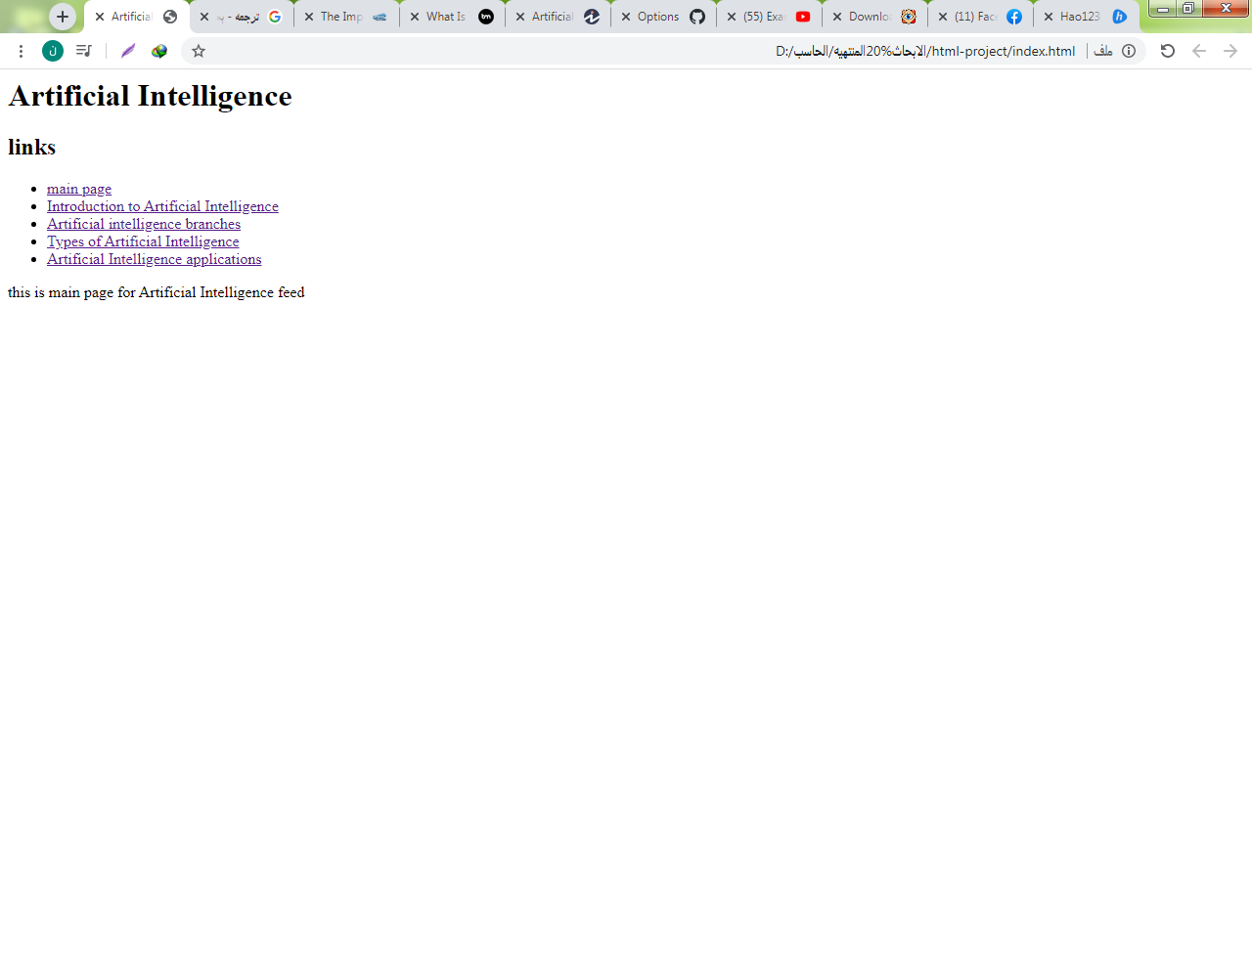**Screenshots:**

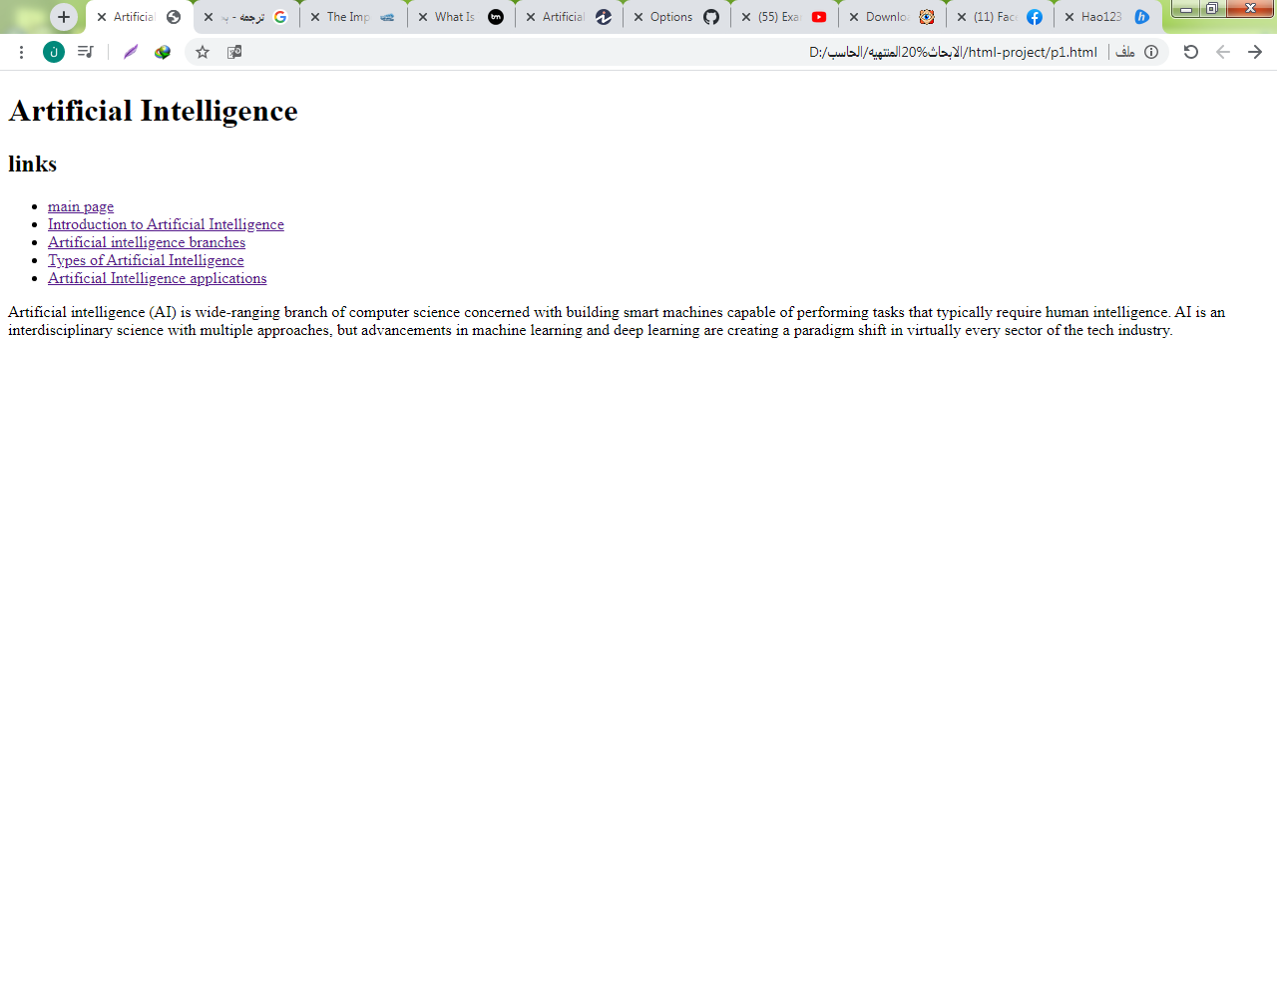

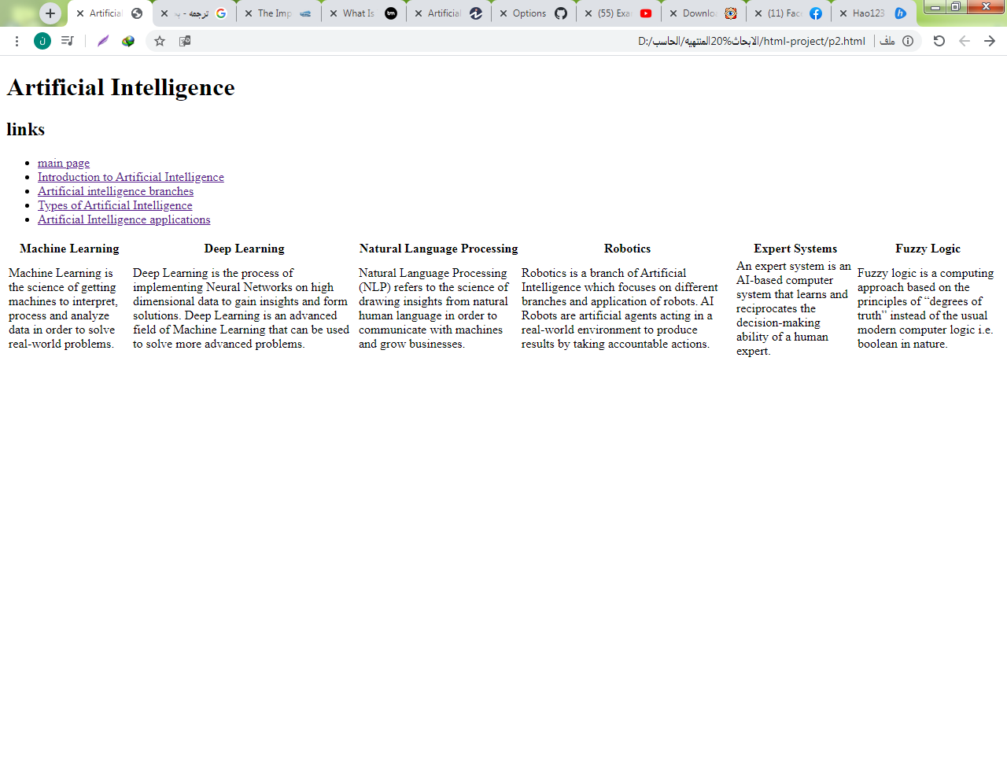

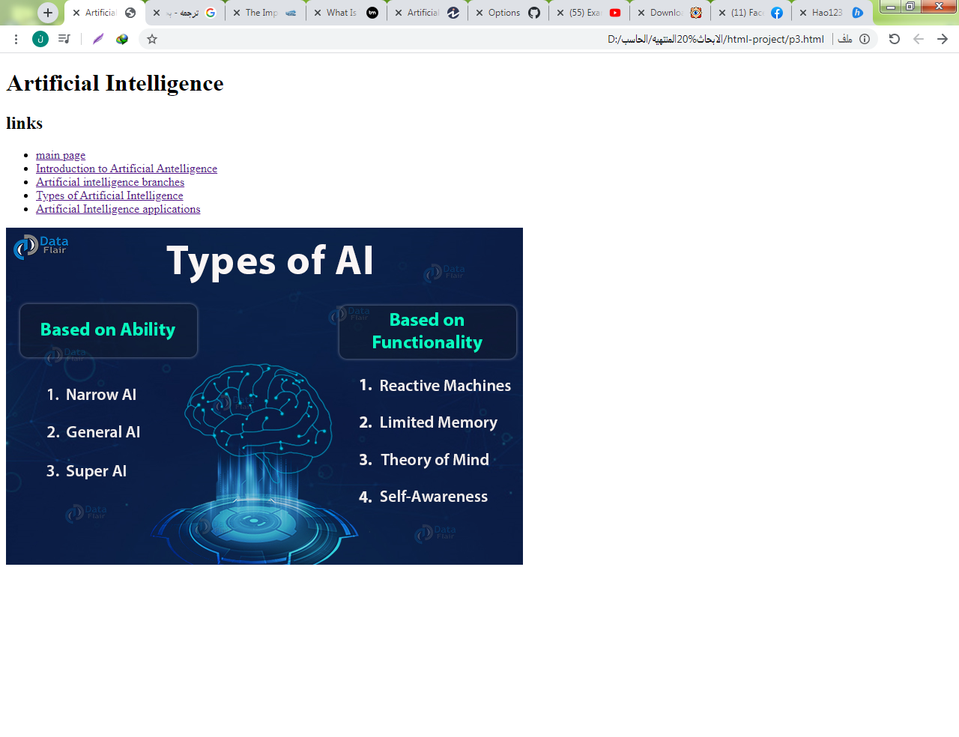

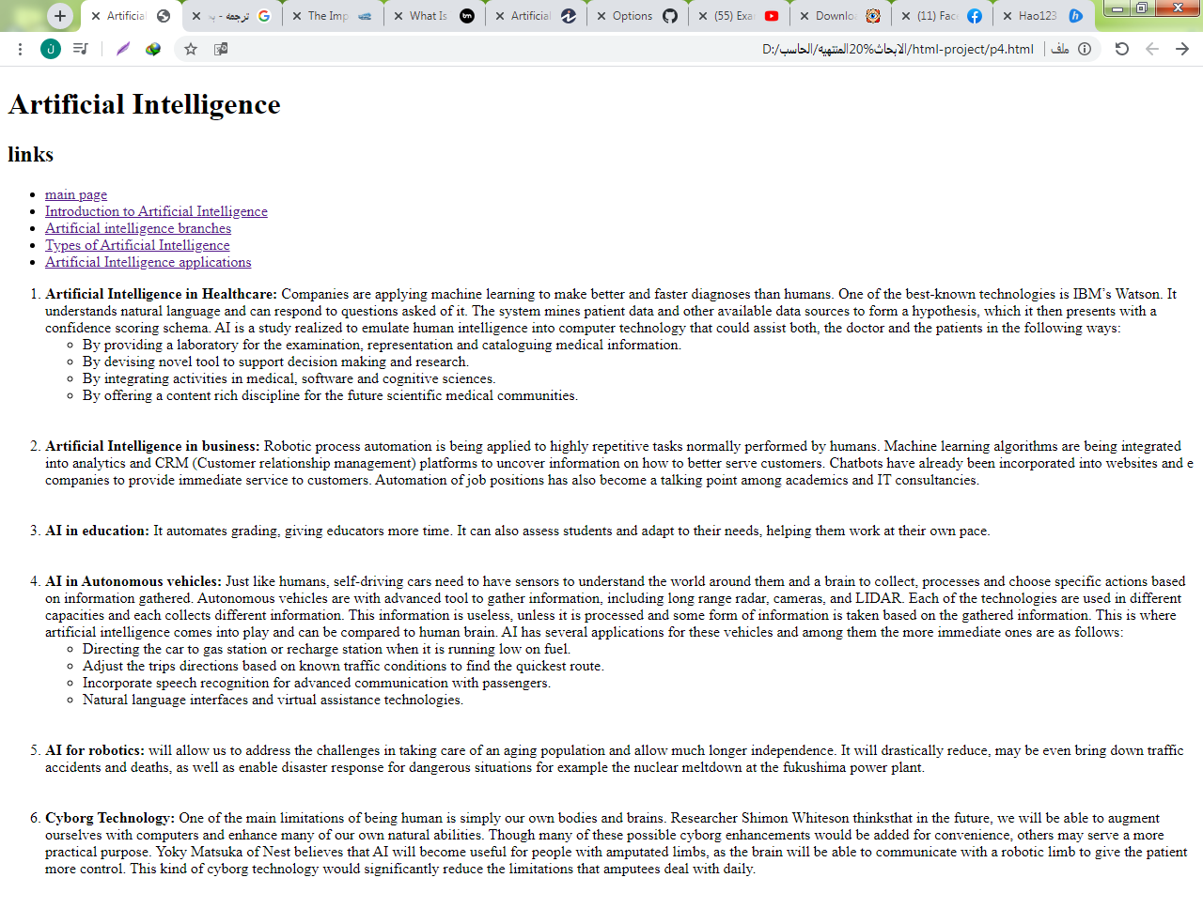

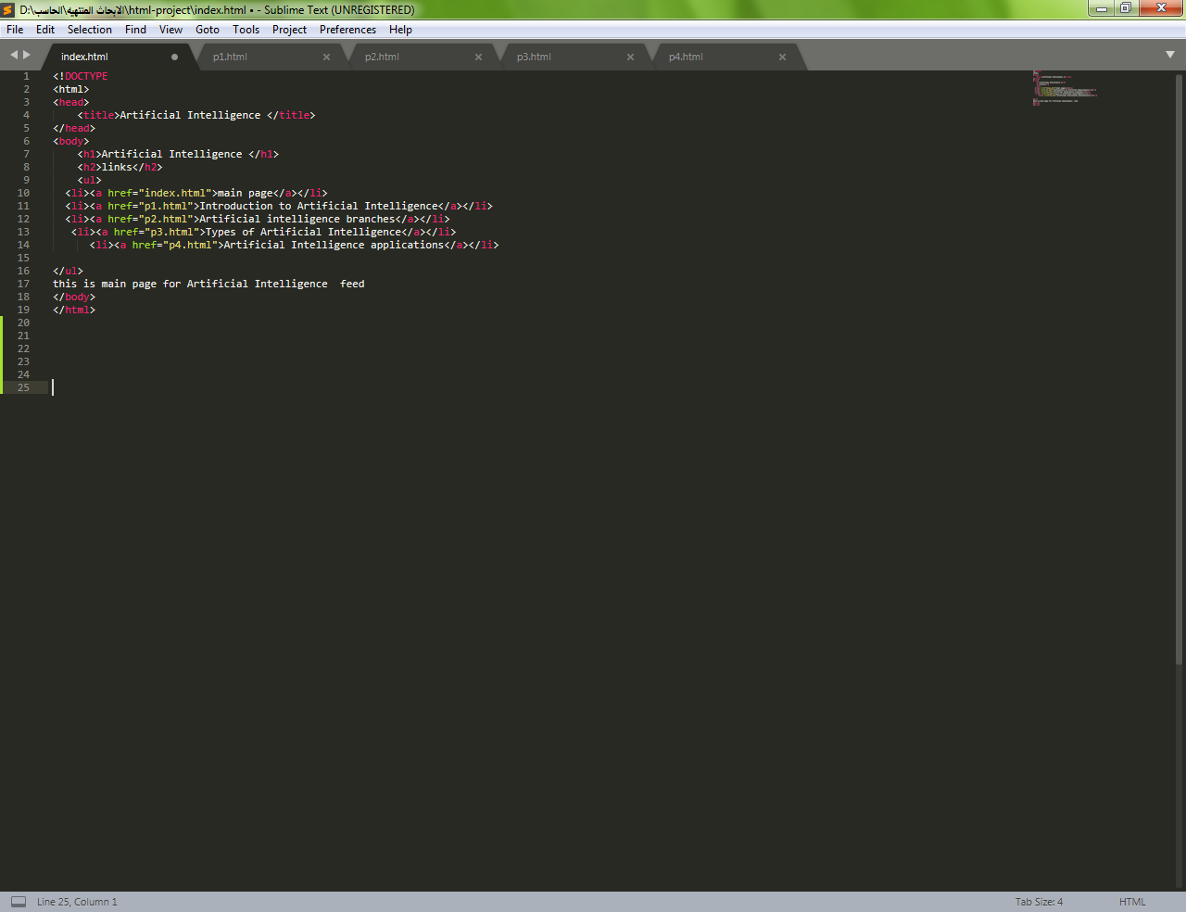**Source code:**

